

WHAT TO BRING TO YOUR DOT PHYSICAL

To avoid delays, please bring the items below that apply to you.

ALL DRIVERS:
- A complete list of ALL medications, including:
  - Name of medication
  - Dose
  - Prescribing doctor’s name and address
- Completed Driver’s Portion (Page 1) of the exam form (optional, but saves time)

If you use VISION OR HEARING AIDS:
- Glasses or contact lenses
- Hearing aids
(You must pass a vision and hearing test.)

If you have HIGH BLOOD PRESSURE:
- Blood pressure must be below 140/90 on exam day.

If you have DIABETES:
- Most recent Hemoglobin A1C (HgA1C) lab result
- Blood sugar logs or records

If you have SLEEP APNEA (CPAP USERS):
- CPAP compliance report
  - Minimum: 90 days
  - Preferred: 1 year
- Letter from sleep specialist (if available)

If you have a HEART-RELATED CONDITION: (Stent, pacemaker, valve replacement, heart attack, bypass, open-heart surgery)
- Cardiologist letter including:
  - Medical history
  - Current medications
  - Clearance to drive
- Recent cardiac testing (stress test, echocardiogram, etc., within 1–2 years)

If you have suffered a STROKE, SEIZURE, BRAIN TUMOR, OR BRAIN BLEED:
- Neurologist letter including:
  - Medical history
  - Current medications
  - Clearance to drive

If you have permanent LOSS OF USE OF ARM/LEG:
- Physician documentation of injury and any work restrictions
- Skilled Performance Evaluation (if required)

If you use MEDICATIONS THAT CAUSE DROWSINESS: (Narcotics, sleep aids, anxiety meds, ADHD meds, controlled substances)
- Doctor’s note confirming you are safe to operate a DOT vehicle

If you take the blood thinner COUMADIN (WARFARIN):
- Recent INR lab result
- Doctor’s clearance letter

IMPORTANT:
Each DOT physical is unique. Additional documentation may be required.
If you are unsure about qualification, see your primary or specialty physician before your certification expires.

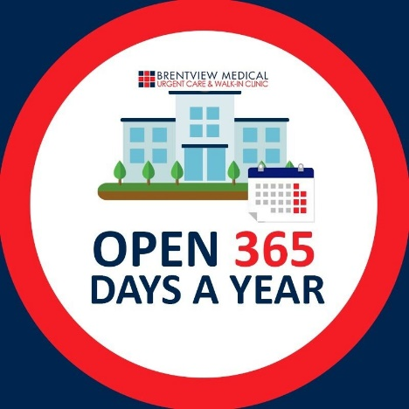
HOURS OF OPERATION

MON-FRI: 8 AM to 6:30 PM
SAT-SUN: 9 AM to 5:30 PM
Last patient accepted 30 mins prior to closing

CLINIC LOCATIONS

BRENTWOOD
11611 San Vicente Blvd.
Los Angeles, CA 90049
(310) 820-0013
﻿
WEST HOLLYWOOD
8264 Santa Monica Blvd.
W. Hollywood CA 90046
(323) 522-2222

