IN CASE OF
WORK RELATED INJURY
- Contact ____________________________ for a
treatment authorization form.
- Go to Brentview Medical. You will receive immediate attention.
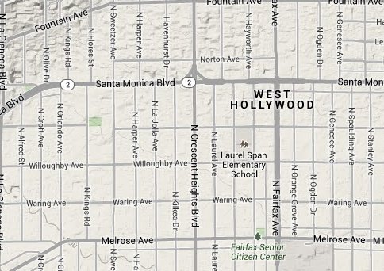
Office Hours | After Office Hours
Monday-Friday: 8:00AM-8:00PM Saturday: 9:00AM-4:00PM  Sunday: 9:00AM-4:00PM | Call 323-522-2222 to have the Physician paged or go to the nearest Emergency Room.(Please follow-up at Brentview Medical)
For life threatening emergencies, call 911

